Ingress Controllers and Resources

What is Ingress?

Everything in Kubernetes is an object. Every object has a controller that watches it for changes and acts accordingly.

Ingress is an API object that manages external access to services in a cluster. Typically, it exposes HTTP and HTTPS routes from outside the cluster to services within the cluster. Traffic routing is defined by rules on the ingress resource.

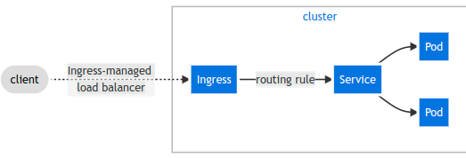
An ingress does not expose arbitrary ports and protocols. Exposing anything other than HTTP or HTTPS to the internet uses a service type such as NodePort or LoadBalancer.

An ingress controller watches for ingress objects, which accept traffic at some host or forward it to a service object such as ClusterIP. Essentially ingress controller is a reverse proxy app that lists on ports 80 and 443 as it monitors the server API server for specific DNS addresses. It is responsible for fulfilling Ingress requests.
For a full list of different types of ingress controller click the following:
https://kubernetes.io/docs/concepts/services-networking/ingress-controllers/
The following example is of an Ingress Controller with a LoadBalancer service type, deployed in front of our cluster. The client will request web traffic on port 80 and according to their DNS name, will be directed to one of three different nodes and 9 different pods. This is the typical setup of an Nginx Ingress Controller. The key
advantage to ingress controllers is seamless integration with cloud loadbalancers such as GCP GLBC.
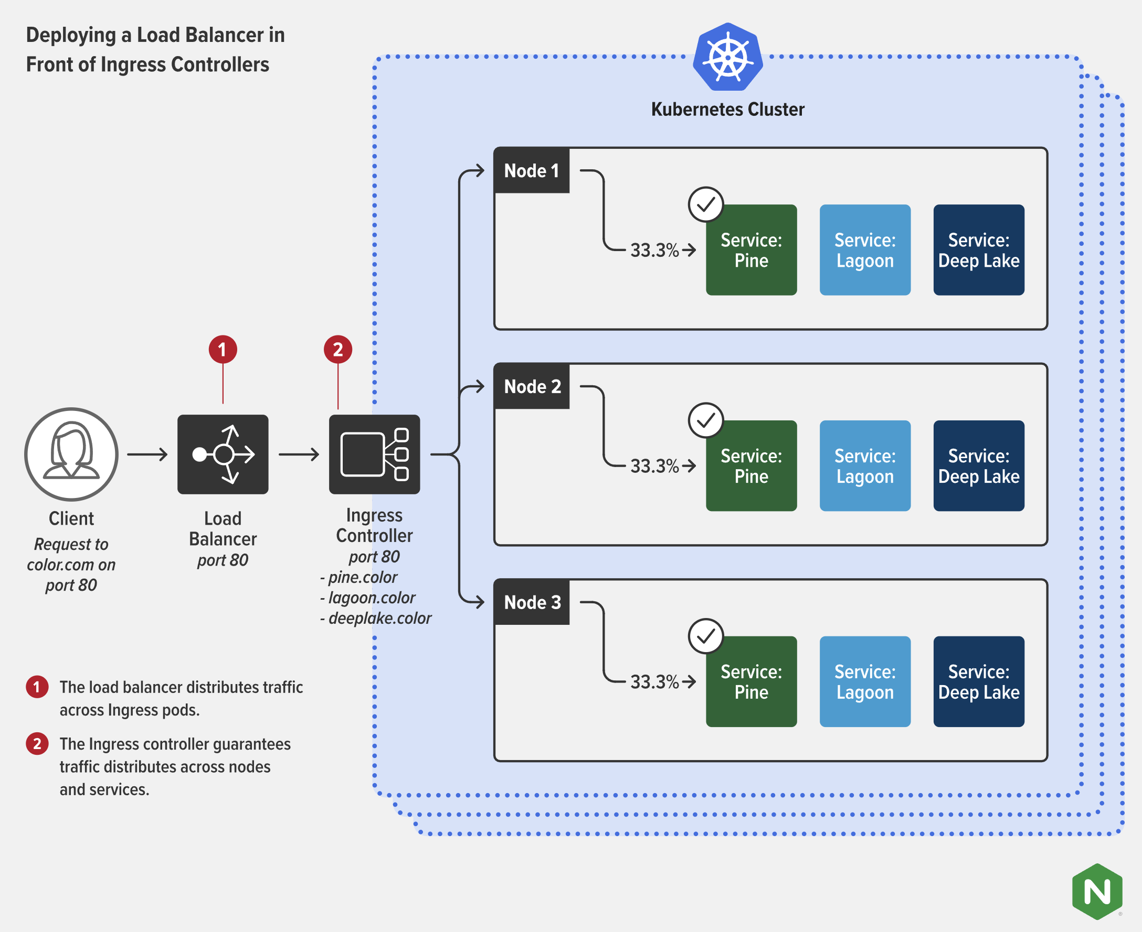

Ingress Resource

This is a minimal ingress resource:
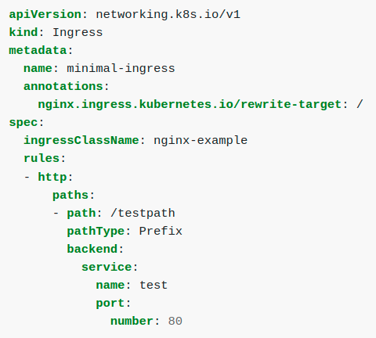

Hands On – Setup Ingress with the Nginx Ingress Controllers

I. Enable the Ingress controller:

To enable the nginx Ingress controller, we need to enable it on the node.

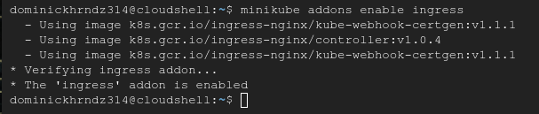
Verify the services is working – it can take up to a minute for all 3 pods to be up and running.
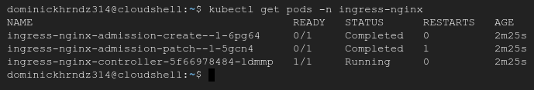
II. Deploy Hello-World app:

Instead of writing an app, we’re going to deploy an existing hello-world app from Google.

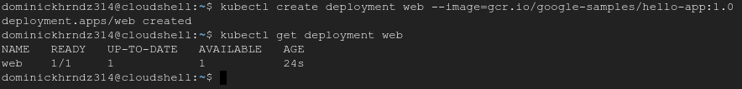
Once you’ve verified it exists, take a look at the deployment in detail. Use the kubectl describe deployment web commands to view information about your deployment. Notice there is no port or host port.

After you’ve described the deployment, check out the pod as well to ensure its in running status.

Now we need to expose the deployment to port 8080 and then we need to verify the service is created. Notice how our service is running NodePort.

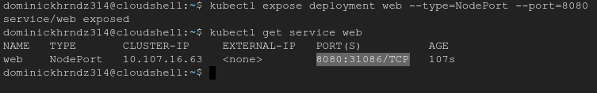
Test your new ‘web’ service by trying to access your app from the Minikube node. To do so execute the minikube service web –-url command. If you receive the following output, your web app and Ingress controller are communicating successfully.

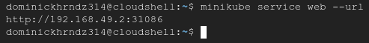

III. Create an Ingress:

Now lets create an Ingress resource that sends traffic to our service via the new application.

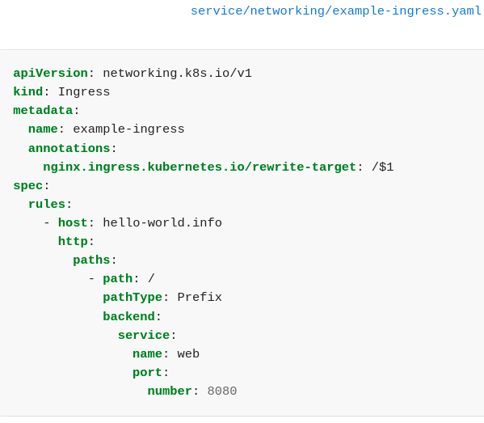

Create the deployment, apply it to the cluster, and verify. Notice that in this deployment our IP address is listed as localhost. This is exclusive to Minikube, but in a regular environment this IP would be different. To get the IP we need on minikube we can execute the minikube ip command.

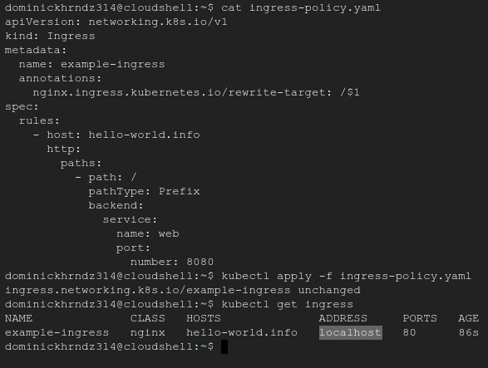
Issue the command and save the IP address.
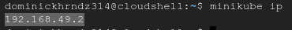
We now need take our IP address and associated with a hostname to create a DNS entry for our Ingress. In GCP cloudshell, navigate to the file path etc/hosts. Add the entry <your minikube IP> hello-world.info
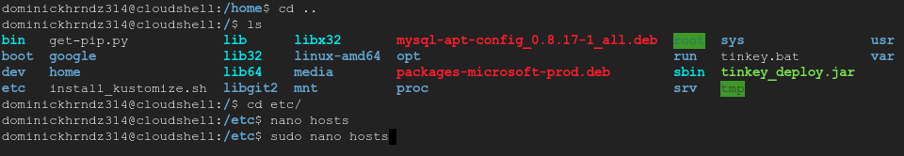

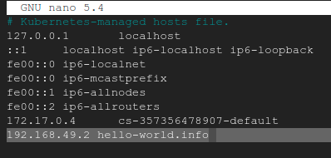

Now let’s verify that the Ingress controller is directing traffic. If you receive the following message then you have completed this training.
